Project plan

TruePartner

By: Simeon Markov
Institution: Fontys UAS
Course: IN-SDE4
Date: 2026-03-19

Inhoudsopgave

1. Project Assignment 3
1.1 Context 3
1.2 Goal of the project 3
1.3 The assignment 3
1.4 Scope 3
1.5 Conditions 3
1.6 Finished products 3
1.7 Research questions 4
2. Approach and Planning 5
2.1 Approach 5
2.2 Research methods 5
2.3 Breakdown of the project 5
2.4 Time plan 5
3. Project organization 6
3.1 Team members 6
3.2 Communication 6
3.3 Test environment 6
3.4 Configuration management 6
4. Finance and Risks 7
4.1 Cost budget 7
4.2 Risks and fallback activities 7
5. Other 8

Project Assignment

Context
The project is about CaaS (Car-As-A-Service) web-based platform for managing renting electrics vehicles with clear policies and transparency. Customers could browse through a selection of available vehicles and find their suitable choice by searching car brands, models, price range, etc.

Goal of the project
The goal of the project is to achieve trust and transparency in the sector by clearly stating fuel policies, insurance coverage… Moreover, the project strives to eliminate emissions by promoting only electric vehicles.

Scope

The project includes: | The project does not include:
- Project plan | - User manual
- Analysis document | - Deployment of the application
- Technical design guide
- Source code documentation
- Test plan

Constraints
Technology
.NET ecosystem constrained technologies, where C# is the core backend language.
Database
MSSQL (relational) database for managing the application’s incoming data.
Deadline
The final deadline for the submission of the project is June 18 by 5pm.
Time to be dedicated
The dedicated time for the project would be every Monday, Tuesday and Friday (morning sessions: 9am-1pm) of the week from 9am-4pm.

Finished products
This section gives an overview of the product breakdown structure.
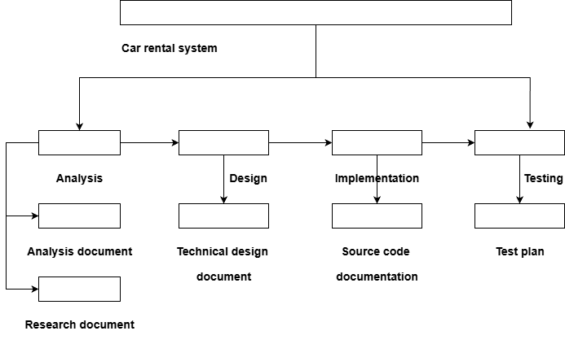
Figure 1: PBS structure diagram

Research questions
Main question: How to build Car-as-a-service (CaaS) platform.

Competitive business model
      - How do emerging mobility services (e.g. car‑sharing, subscriptions) affect demand for traditional car rental in Dutch urban areas?
      - How does the Dutch rental services adapt to the changing environmental regulations?

Market demand
      - What are the main decisions behind a typical rental (tourism, urban needs…).

Service quality & trust
      - Which aspects of service quality (e.g. transparency of fees, vehicle condition, staff behaviour, digital usability) affect the most customer’s satisfaction.

1.6.4. Already Available software solutions and used technologies

Approach and Planning

Approach
For this project, I will go for the scrum methodology. By following the agile framework, the work would be divided into several sprints and before moving to the next iteration, the previous must have been validated. To keep track of the project’s development progress, I will use a project management system (ClickUp).

Test approach
Functional testing: For that kind of testing, unit tests will be performed, ensuring that each component is correctly working. Moreover, abstract tests scenarios would be created for checking up with the requirements and catching errors in early stages.
Regression & usability testing: Use cases would be constructed at a later stage, confirming the final stage of the application, checking different aspects of the application (UI misalignment, functional features, etc.).
Derivable: Complete test plan, test cases & final test report (quality assurance, technical dept, performance…).

Research methods
Literature Study: I will use this method to conduct my general research on the topic of car rental uprising services, market growth, EU regulations, etc.
Survey: Collecting relevant information about user interests, when do customers tend to rent a vehicle, occasions?
Peer Review: Asking for feedback from coaches, co-student, seeking validation on different functionalities.
Prototyping: Wireframing for presenting the concept, catching up with expectations early.
Proof of Concept: Presenting an MVP for idea validation.
Comparison Chart: Analysing and comparing trends in the market.

Breakdown of the project
This section presents a rough representation of the phases, sprints of the project.
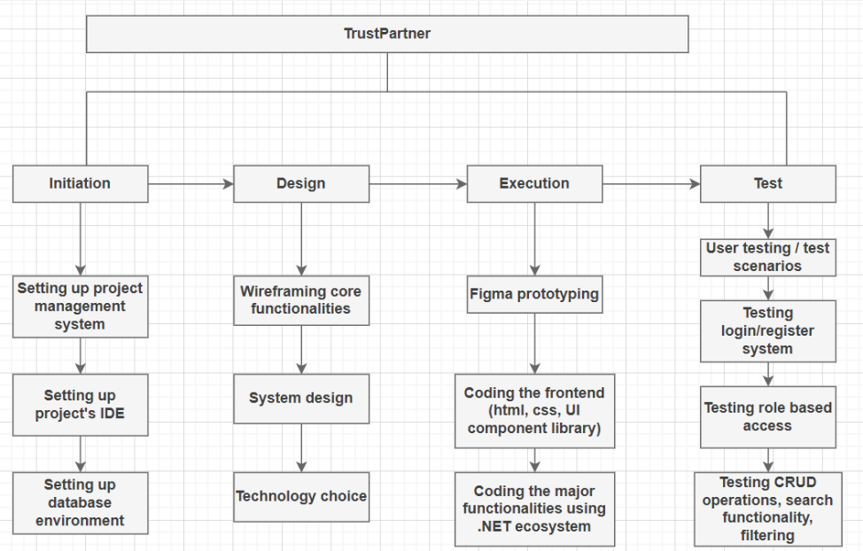
Figure 2: WBS diagram

Time plan
The workload is divided into several sprints and each sprint has a given time interval.

Phasing | Effort | Start | End
Sprint 0 (Initial planning and analysis) | 1 week | 02.03.2026 | 11.03.2026
Sprint 1 (Setting up database, project design architecture, wireframing, authentication & index page) | 1 week | 12.03.2026 | 20.03.2026
Sprint 2 (search, filter functionality on lists of vehicles and designing contact page) | 1.4 weeks | 20.03.2023 | 31.03.2026
Sprint 3 (Renting functionality) | 2.4 weeks | 01.04.2026 | 18.04.2026
Sprint 4 Option for users to change timeslot) | 1.6 weeks | 19.04.2026 | 04.05.2026
Sprint 5 (Admin dashboard, role-based access & CRUD operations) | 2.4 weeks | 05.05.2026 | 23.05.2026
Sprint 6 (Rating functionality integrated) | 3.5 weeks | 24.05.2026 | 18.06.2026
Table 1: Sprints time distribution

For remainder I am using the integrated calendar of the product management system ClickUp:

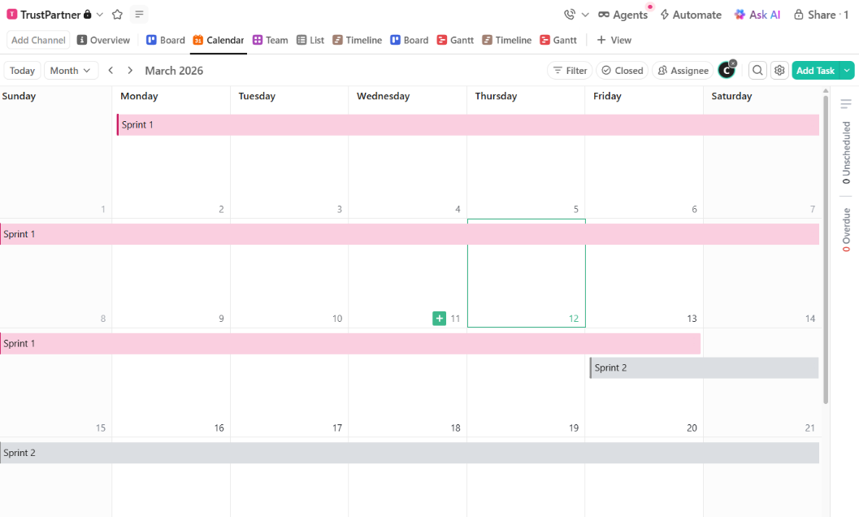
Figure 3: (Partial) View of the calendar for the different sprints

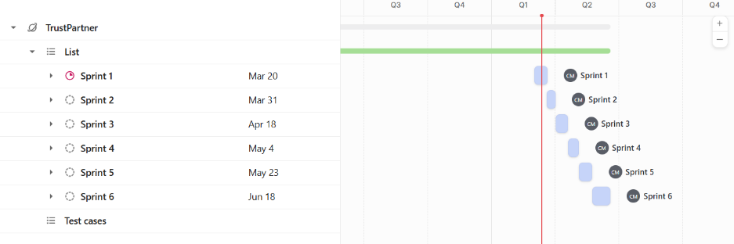
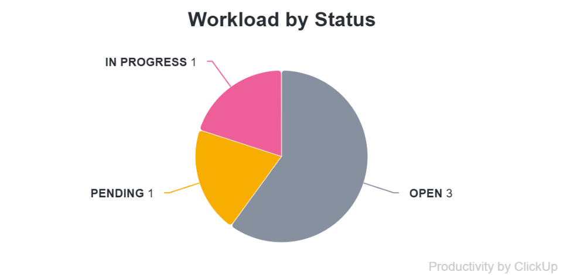
Current workload distribution, filtered by task’s status and deadline:
Figure 4: Gantt chart, sorted by deadline
Figure 5: Workload by status

Project Organization

Configuration management
For this project, version control system (Git) is used to keep track of history changes during the development cycle. The branching strategy that is going to be used is the GitFlow with branches: main, develop, feature and release.
Flow of branches:
main: Production ready code is pushed to the main.
develop: This branch is the development stage of the application.
feature: Every new major functionality is added through this branch then it’s merged with the develop branch.
release: This is the stage of the application that has just enough features to be tested (MVP). After that this branch is merged with the production one (main branch).

